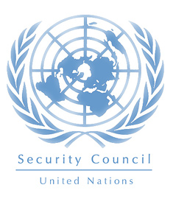

**Security Council**

**Note from the Presidents:**

Welcome delegates to the Security Council (SC). It will be a pleasure to have you during our debate; we hope your best effort and your best attitude among the situation we are treating, abolishing the right of veto or changing the way it is used un the actual council. In this guide you will learn how the council works for you to be prepared for the debate.

**VETO:**

The veto is the right that some delegations have, it allows the country to have entire control on the decisions that are taken in the UN, and their vote is absolute. This means that if one of those countries votes against any proposal, it cannot pass so it has to be written again. These countries are: United States, Russia, France, Unites Kingdom, and China.

**About the committee:**

* The Security Council takes the lead in determining the existence of a threat to the peace or act of aggression. It calls upon the parties to a dispute to settle it by peaceful means and recommends methods of adjustment or terms of settlement. In some cases, the Security Council can resort to imposing sanctions or even authorize the use of force to maintain or restore international peace and security.
* 15 members: 5 permanent (vetos), and 10 countries that last two years in the council and then rotate with others.
* Meetings are called at any time when the need arises.
* Presidency rotates between the members in a lapse of time of one month.

**-Premise:**

**“Does the Security Council need a reform in the power of veto and the way conflicts are being solved? How can developing countries benefit from this?”**

As you know the Security Council is the meeting in which any proposal is submitted to voting. If one of the 5 permanent members votes against any solution, it must be rewritten. Developing countries are affected because of this and it is not fair that just 5 delegations have the right to choose by all the rest.

In other words these members hold the entire power of the UN and as a consequence all the affairs that deal with international peace and security are solved and analyzed by them.

During the committee the delegates and the presidents will work just as the real SC does and they will try to reach a viable reform for the council.

*Any questions to the E-mail: warrenf228@gmail.com

Attentively: Santiago Arrieta / Felipe Warren